30-04-22

TODAYS AGENDA :------

* Python unit testing
* CLASS TASK----------

Create a python file that will have a class. Inside the class youneed to create methods for :-

1.) converting a string to uppercase

2.) converting a string to lower case

After doing it check whether the output is TRUE/FALSEbased on input ?

***********************************************************************

**PYTHON UNIT TESTING**

It is a process through which we can test a particular module for any errors.

Python Unit Testing gives us the edge of analyzing, detecting and create a hotfix for out code.

Python unit testing gives us the tool for understanding the way a developer writes a code.

**Types of Testing**

1. Manual testing
2. Automated testing

* In manual testing a man has to do the testing. It is time consuming because it is being done by a man which is without any plan. The code may also changes according to the input provided.

* In automation testing everything is being planned earlier and it is being scripted onto a code block. So, there is no way the results are being done and it takes time.

**Unit testing Vs Integration Testing**

* Unit testing is done to check the small functions, methods of a class
* Integration testing is done to check the overall program
* Unit testing is done at atomic level.
* Integration testing is done at a large scale.
* Kindly note that if you are doing Integration testing the results may be full of errors and you may not find the specific problem. So, you have to be cautious about it.

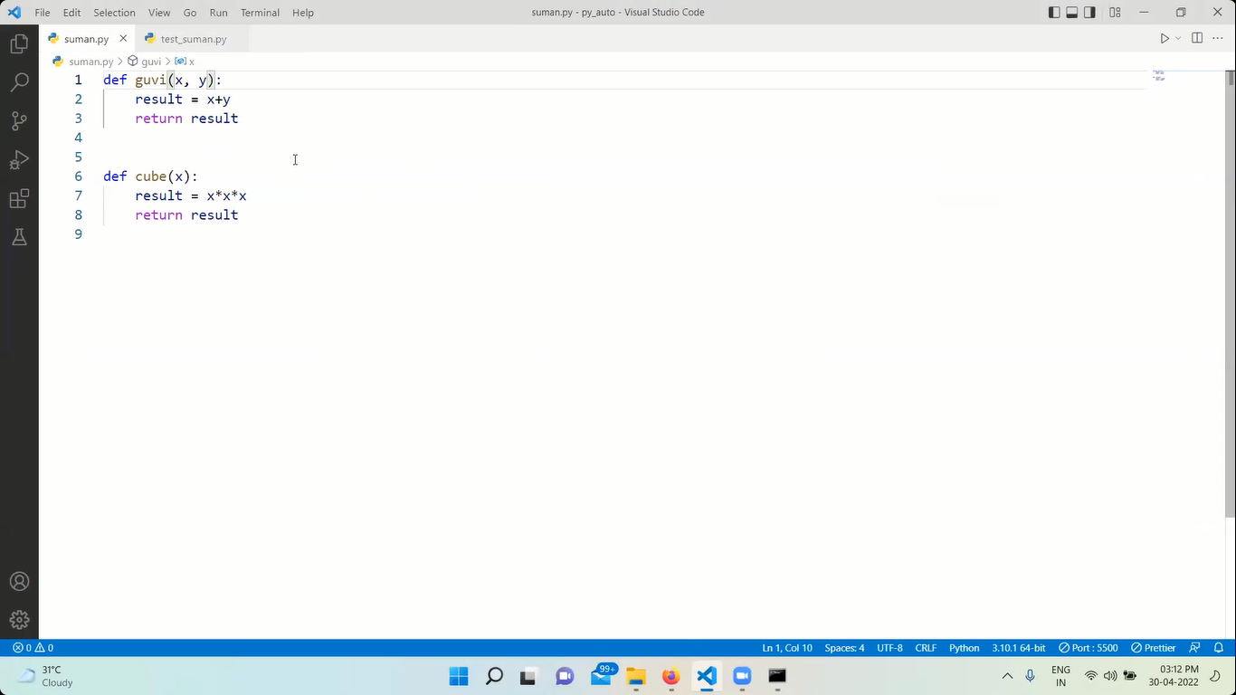

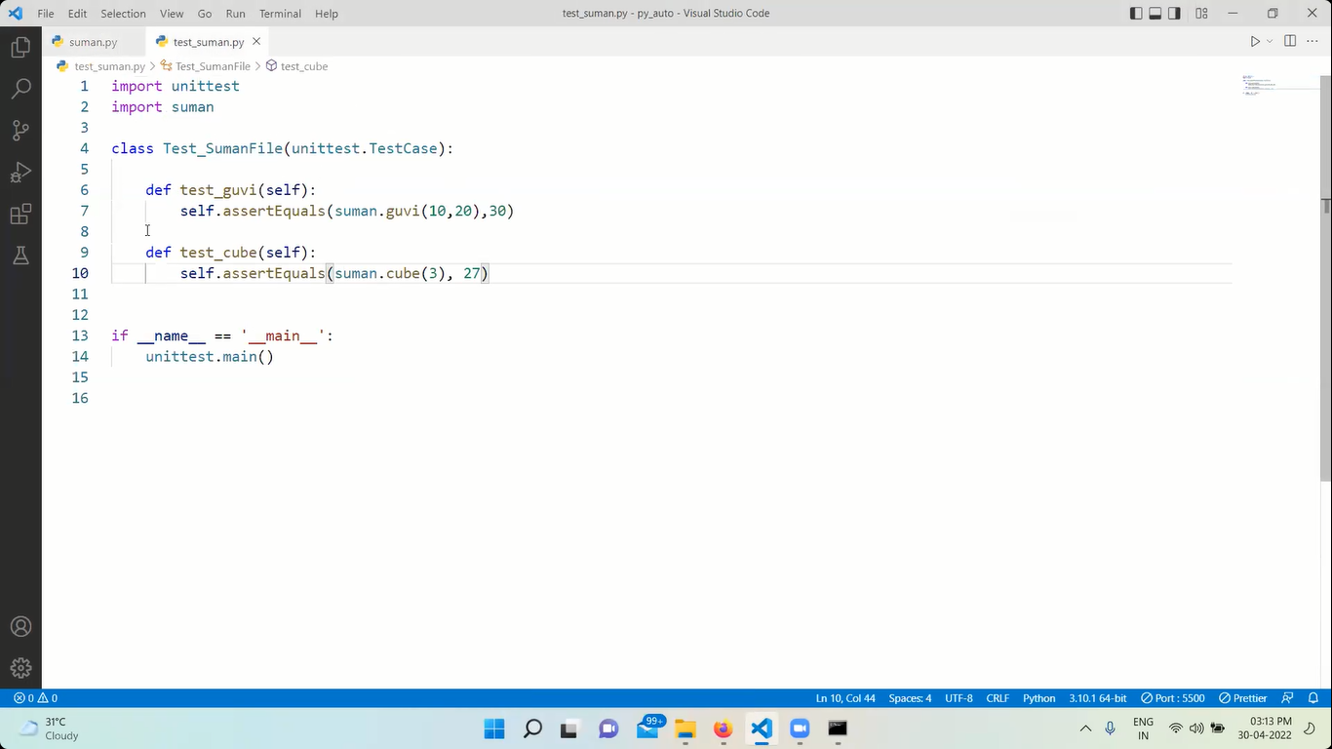

******************************************************************

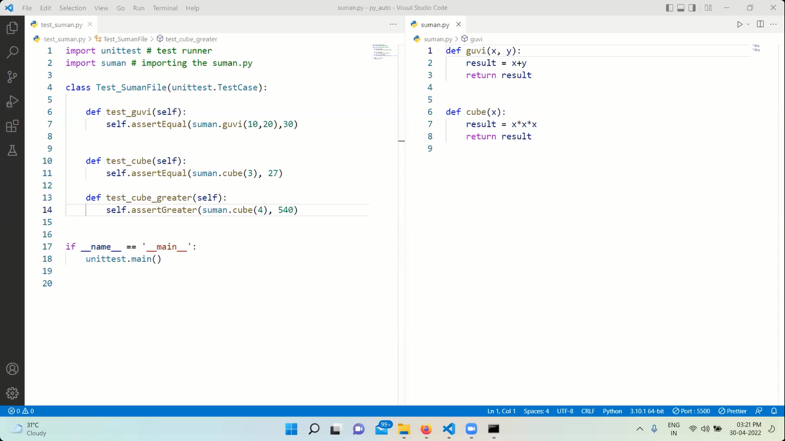

***********************************************************

TASK

